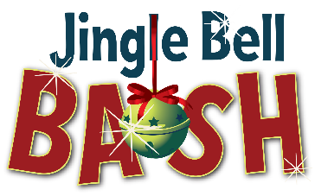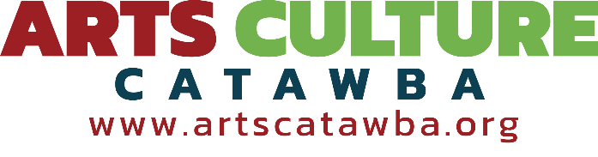
243 3rd Ave NE, Box 5  Hickory, NC  28601  (828) 324-4906x301  adminassist@artscatawba.org
Jingle Bell BASH – December 8, 2025 – ITEMS DUE Nov 24, 5:00 PM
See ACC Silent Auction Donation Policy on reverse side of this form.
Donor Information: Email Address:

Name: ______________________________________________________________________________
(As you would like it listed in the program)

Address: ______________________________________________________________________________

City, State, Zip: Phone: ______________________________________________________________________________
Phone: ____________________________ Email: ________________________________________________
Donation Information: Insurance Value: Artist’s minimum portion:
(if applicable)
Name of Item(s):

_________________________________ $______________ $____________

_________________________________ $______________ $____________

Artist statement about this work (Please email adminassist@artscatawba.org a picture of item(s) if possible):

_____________________________________________________________________

_____________________________________________________________________

Please Initial: ARTISTS ONLY Please Initial:
I would like to donate this item to the Silent Auction and have 100% of the proceeds go toward Innovative Artist Grants.
I would like to receive 50% of the amount of the final bid for my artwork. The minimum amount I will accept for my portion is $___________. Minimum value of an art piece donated for a 50-50 split must be $100.

If item is unsold, I would like it:
Returned Saved for next year’s Auction
If returned, donor must pick up item from ACC’s office within the following week.

____________________________________________________
Donor Signature

Arts Culture Catawba
POLICY FOR DONATIONS TO SILENT AUCTION
JINGLE BELL BASH

Arts Culture Catawba (ACC) is grateful for donations to the Jingle Bell BASH Silent Auction, which funds our Innovative Artist Grant.

With the goal of a high-quality Silent Auction, we will accept donations with the following provisions:

- Donations of new home furnishings and original art will be emphasized.

- Artists (only) may opt to reserve 50% of the proceeds from their donated items under the following parameters:
  - Donation must be an original work of art from the artist.
  - Minimum value of an art piece donated for a 50-50 split must be $100. Artwork without a 50% reserve may be of lesser value.
  - A minimum bid must be specified and agreed upon at time of donation and it will be noted on the bid sheet as “Per the Artist’s Request.”

- Original works by a donor who is not the artist will be accepted but will not qualify for the 50-50 split.

- Gift certificates for services are appreciated, but only with a minimum value of $50, and are not eligible for a 50-50 split.

All donations must be made and in ACC’s possession at least 2 weeks before the day of the event.

Unsold items may be returned to the donor, stored for the next auction or donated to another nonprofit organization, at the discretion of ACC. If returned to the donor, unsold items must be picked up from ACC’s office within one week after the event.

